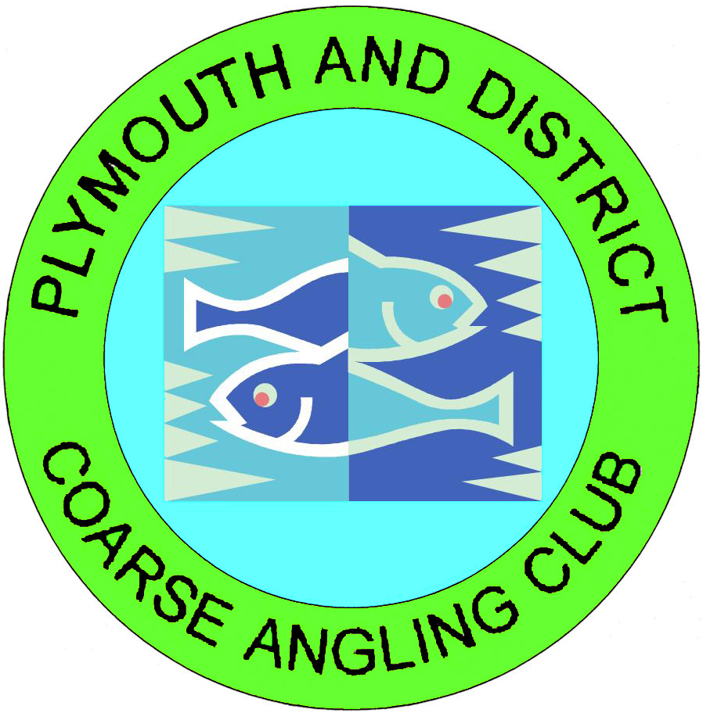

Dear member It’s that time of year again when we need to think about the new committee for the coming year, please use return to me the enclosed nomination form should you wish to nominate anyone but please read the notes on nominations first. This year because of the Corona virus a live AGM at a venue is not possible so we are going to do it online via a zoom meeting,This is challenging but possible. Should you wish to attend this zoom meeting you will need a means of getting online and a microphone and camera(Most smart phones will do this). Look out for the links and the how to take part info that will be posted on Facebook and our website in the next couple of weeks. .despite the corona virus and the slow down of the economy we have just about maintained our membership numbers to only a few less than last year and look to be in good shape going forward. Financially we are sound and have carried out major maintenance work at all the lakes and stocked fish into Filham and Cadover.The roping of Filham and Weedy lakes will be carried out in October and remain until the spring to protect against Cormorants. Also enclosed is a committee proposal for constitutional changes which we feel will improve the club and the committee itself. This will be discussed at the AGM but if you have any questions regarding it please feel free to message or email me.

**The ibook system**

As you will all now know the new ibook system came into force on the 1st of October and you should now use this to book your swims when you want to fish the lakes. It is pretty much instant and completely changeable if circumstances change on the day. In the event of any problems you can still ring either Gary Beasley, Mark Chanter or myself and we can book you in manually. From the 1st of December you will also be able to join and rejoin the club online using the ibook app. The App is available through our website and facebook pages just click the link. There is also a helpful little link that will let you look at what pegs are already booked which you may want to look at before you decide where you wish to fish this is located on the front page of the clubs website at [www.padcac.co.uk](http://www.padcac.co.uk). Again for anyone who struggles help is a phone call away or you can still join at Fishing Mayhem, Liskeard or Robs Bait and Tackle at Pasley street in Plymouth.

***W R Cox, secretary P.A.D.C.A.C***